Khajuraho Group of Monuments
The Khajuraho Group of Monuments are a group of Hindu and Digambara Jain temples in Chhatarpur district, Madhya Pradesh, India. They are about 46 km (28.6 mi) from Chhatarpur city, the district headquarters, 283 km (177 mi) from Gwalior, 175 kilometres (109 mi) southeast of Jhansi, 10 kilometres (6.2 mi) from Khajwa and 9 kilometres (5.6 mi) from Rajnagar. The temples are famous for their Nagara-style architectural symbolism and a few erotic sculptures.
Most Khajuraho temples were built between 885 CE and 1000 CE by the Chandela dynasty. Historical records note that the Khajuraho temple site had 85 temples by the 12th century, spread over 20 square kilometres (7.7 mi²). Of these, only about 25 temples have survived, spread over six square kilometres (2.3 mi²). Of the surviving temples, the Kandariya Mahadeva Temple is decorated with a profusion of sculptures with intricate details, symbolism, and expressiveness of ancient Indian art.The temple complex was forgotten and overgrown by the jungle until 1838 when Captain T.S. Burt, a British engineer, visited the complex and reported his findings in the Journal of the Asiatic Society of Bengal.
When these monuments were built, the boys in the place lived in hermitages, by being brahmacharyas (bachelors) until they attained manhood and these sculptures helped them to learn about the worldly role of 'householder'.The Khajuraho group of temples were built together but were dedicated to two religions, Hinduism and Jainism, suggesting a tradition of acceptance and respect for diverse religious views among Hindus and Jains in the region.Because of their outstanding architecture, diversity of temple forms, and testimony to the Chandela civilization, the monuments at Khajuraho were inscribed on the UNESCO World Heritage List in 1986.
History
The Khajuraho group of monuments was built during the rule of the Chandela dynasty. The building activity started almost immediately after the rise of their power, throughout their kingdom to be later known as Bundelkhand. Most temples were built during the reigns of the Hindu kings Yashovarman and Dhanga. Yashovarman's legacy is best exhibited by the Lakshmana Temple. Vishvanatha temple best highlights King Dhanga's reign.The largest and currently most famous surviving temple is Kandariya Mahadeva built in the reign of King Vidyadhara. The temple inscriptions suggest many of the currently surviving temples were complete between 970 and 1030 CE, with further temples completed during the following decades.The Khajuraho temples were built about 35 miles from the medieval city of Mahoba, the capital of the Chandela dynasty, in the Kalinjar region. In ancient and medieval literature, their kingdom has been referred to as Jijhoti, Jejahoti, Chih-chi-to and Jejakabhukti.
The first documented mention of Khajuraho was made in 641 by Xuanzang, a Chinese pilgrim who described encountering several dozen inactive Buddhist monasteries and a dozen Hindu temples with a thousand worshipping brahmins.In 1022 CE, Khajuraho was mentioned by Abu Rihan-al-Biruni, the Persian historian who accompanied Mahmud of Ghazni in his raid of Kalinjar; he mentions Khajuraho as the capital of Jajahuti.The raid was unsuccessful, and a peace accord was reached when the Hindu king agreed to pay a ransom to Mahmud of Ghazni to end the attack and leave.
Khajuraho temples were in active use through the end of the 12th century. This changed in the 13th century; after the army of Delhi Sultanate, under the command of the Muslim Sultan Qutb-ud-din Aibak, attacked and seized the Chandela kingdom. About a century later, Ibn Battuta, the Moroccan traveller in his memoirs about his stay in India from 1335 to 1342 CE, mentioned visiting Khajuraho temples, calling them "Kajarra”.
Description
The temple site is within Vindhya mountain range in central India. An ancient local legend held that Hindu deity Shiva and other gods enjoyed visiting the dramatic hill formation in Kalinjar area. The center of this region is Khajuraho, set midst local hills and rivers. The temple complex reflects the ancient Hindu tradition of building temples where gods love to pray.
The temples are clustered near water, another typical feature of Hindu temples. The current water bodies include Sib Sagar, Khajur Sagar (also called Ninora Tal) and Khudar Nadi (river). Local legends state that the temple complex had 64 water bodies, of which 56 have been physically identified by archeologists so far.
All temples, except one (Chaturbhuja) face the sunrise – another symbolic feature that is predominant in Hindu temples. The relative layout of temples integrate masculine and feminine deities and symbols highlight the interdependence. The artworks symbolically highlight the four goals of life considered necessary and proper in Hinduism – dharma, kama, artha and moksha.Of the surviving temples, six are dedicated to Shiva, eight to Vishnu and his affinities, one to Ganesha, one to Sun god, three to Jain Tirthankars.For some ruins, there is insufficient evidence to assign the temple to specific deities with confidence.
An overall examination of site suggests that the Hindu symbolic mandala design principle of square and circles is present each temple plan and design.Further, the territory is laid out in three triangles that converge to form a pentagon. Scholars suggest that this reflects the Hindu symbolism for three realms or trilokinatha, and five cosmic substances or panchbhuteshvara.The temple site highlights Shiva, the one who destroys and recycles life, thereby controlling the cosmic dance of time, evolution and dissolution.
The temples have a rich display of intricately carved statues. While they are famous for their erotic sculpture, sexual themes cover less than 10% of the temple sculpture. Further, most erotic scene panels are neither prominent nor emphasized at the expense of the rest, rather they are in proportional balance with the non-sexual images.The viewer has to look closely to find them, or be directed by a guide. The arts cover numerous aspects of human life and values considered important in the Hindu pantheon. Further, the images are arranged in a configuration to express central ideas of Hinduism. All three ideas from Āgamas are richly expressed in Khajuraho temples – Avyakta, Vyaktavyakta and Vyakta.
The Beejamandal temple is under excavation. It has been identified with the Vaidyanath temple mentioned in the Grahpati Kokalla inscription.Of all temples, the Matangeshvara temple remains an active site of worship.It is another square grid temple, with a large 2.5 metres (8.2 ft) high and 1.1 metres (3.6 ft) diameter lingam, placed on a 7.6 metres (25 ft) diameter platform.
The most visited temple, Kandariya Mahadev, has an area of about 6,500 square feet and a shikhara (spire) that rises 116 feet
History of Khajuraho
Khajuraho is a historic temple complex in Madhya Pradesh, India, famous for its magnificent temples and detailed stone sculptures. The temples were mainly built between the 9th and 12th centuries CE, during the rule of the Chandela dynasty.
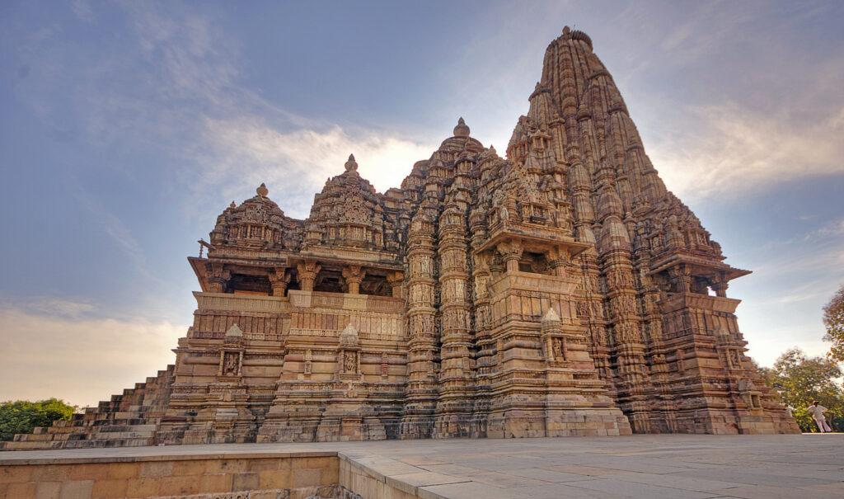

1. Origin and Chandela Dynasty
The Chandelas established their power in the region around the 9th century CE. Khajuraho became an important religious and cultural centre under their rule.The earliest temples are generally associated with the reign of Yashovarman (c. 925–950 CE). His successor Dhanga (c. 950–1002 CE) continued the temple-building tradition and helped make Khajuraho a major centre of temple architecture.

2. Golden Period
Khajuraho reached its architectural peak during the 10th and 11th centuries. The Chandelas constructed numerous Hindu and Jain temples dedicated to deities such as Shiva, Vishnu, and Devi, as well as Jain Tirthankaras.Important temples include:
- Kandariya Mahadeva Temple – dedicated to Shiva and one of the finest examples of Nagara architecture.
- Lakshmana Temple – dedicated to Vishnu.
- Vishvanatha Temple – dedicated to Shiva.
- Devi Jagadambi Temple – associated with Devi.
- Chitragupta Temple – dedicated to Surya.
- Parshvanatha Temple – an important Jain temple.

3. Why are the sculptures famous?
Khajuraho's walls are covered with thousands of sculptures depicting gods and goddesses, musicians, dancers, warriors, animals, everyday activities, and couples.
The erotic sculptures are only one part of a much larger sculptural programme. They are often interpreted in connection with ideas of human life, fertility, spirituality, and the broader religious and cultural traditions of the period.

4. Decline of Khajuraho
By the 12th century, Chandela political power began to decline because of conflicts with neighbouring kingdoms and later Muslim rulers.As political centres shifted, Khajuraho gradually lost its former importance. Many temples were abandoned, and vegetation and natural weathering affected the monuments.However, unlike some ancient sites, many of Khajuraho's temples survived relatively intact.

5. Rediscovery
Khajuraho became less prominent over the centuries and was largely surrounded by forests. In the 19th century, British surveyors and archaeologists brought greater attention to the monuments.
The temples were subsequently documented, studied, and conserved.

6. UNESCO World Heritage Site
The Khajuraho Group of Monuments was inscribed as a UNESCO World Heritage Site in 1986 because of its exceptional artistic and architectural significance.
Geographical Features of Khajuraho

1. Location
- State: Madhya Pradesh
- District: Chhatarpur
- Region: Bundelkhand
- Coordinates: approximately 24.85° N, 79.92° E
- The town lies in the northern part of Madhya Pradesh, between the Vindhyan highlands and the plains of Bundelkhand.
- It is situated at an elevation of roughly 280 m above sea level.

2. Terrain and Landforms
Khajuraho lies in a landscape of gently undulating plains, rocky outcrops and low hills.
The wider Bundelkhand region is characterised by:
- Hard granite and sandstone rock formations
- Low plateaus and hills
- Open agricultural plains
- Seasonal streams and shallow valleys
This geological environment provided suitable building stone, particularly sandstone, which was extensively used in the construction of the temples.

3. Rivers and Water Resources
Khajuraho is situated within the Bundelkhand river system. Several seasonal streams drain the surrounding area, while rivers such as the Ken and its tributaries are important to the wider regional landscape.
Historically, water was important for:
- Agriculture
- Drinking and domestic use
- Religious activities
- Maintaining ponds and reservoirs
The temple complex also had water bodies and tanks, which formed an important part of the traditional settlement landscape.

4. Climate
Khajuraho has a tropical wet-and-dry climate, typical of much of central India.
There are three major seasons:
Summer – March to June
- Very hot and dry.
- Temperatures can rise above 40°C.
- May and June are generally the hottest months.
Monsoon – June to September
- Most of the annual rainfall occurs during this period.
- The landscape becomes considerably greener.
- Heavy seasonal rainfall feeds local streams and water bodies.
Winter – November to February
- Generally cool and dry.
- Days are comfortable, while nights can become relatively cold.

5. Vegetation
The natural vegetation around Khajuraho consists mainly of dry deciduous vegetation.Common vegetation in the broader region includes:
- Teak
- Acacia
- Neem
- Mahua
- Palash
- Various grasses and shrubs
During the monsoon, the surrounding landscape becomes green, while the dry season gives it a much more brown and arid appearance.

6. Soil
The region has a mixture of red, brown and alluvial soils, depending on the local geology and drainage.Agriculture in the surrounding region commonly includes crops such as:
- Wheat
- Gram
- Pulses
- Mustard
- Sorghum

7. Geological Importance
One of Khajuraho's most important geographical advantages was the availability of high-quality sandstone.The Chandelas used sandstone extensively because it could be:
- Carefully cut and shaped
- Finely carved
- Used for highly detailed sculptures
This helped the craftsmen create the elaborate carvings for which Khajuraho is famous.

8. Influence of Geography on the Temples
The geographical environment influenced Khajuraho's architecture in several ways:
Local stone → availability of sandstone supported large-scale temple construction.
Climate → temple construction and drainage had to cope with seasonal monsoon rainfall.
Terrain → temples were built on raised platforms, giving them a strong visual presence above the surrounding landscape.

Damaged Parts of Khajuraho Temples
Khajuraho has suffered damage over many centuries, but it is important to distinguish between entire temples that were lost and parts of surviving temples that are damaged. UNESCO records that the Chandella-period complex originally contained around 85 temples, while only about 22–23 survive today; many of the others survive only as ruins or archaeological mounds.

1. Sculptures and Carvings
Some sculptures have broken or missing faces, arms, hands and other projecting elements. Sculptures are particularly vulnerable because these parts protrude from the stone.
Damage has occurred through a combination of historical human activity, weathering and natural deterioration. UNESCO acknowledges that some sculptures have been damaged, although their overall iconographic features remain sufficiently clear.
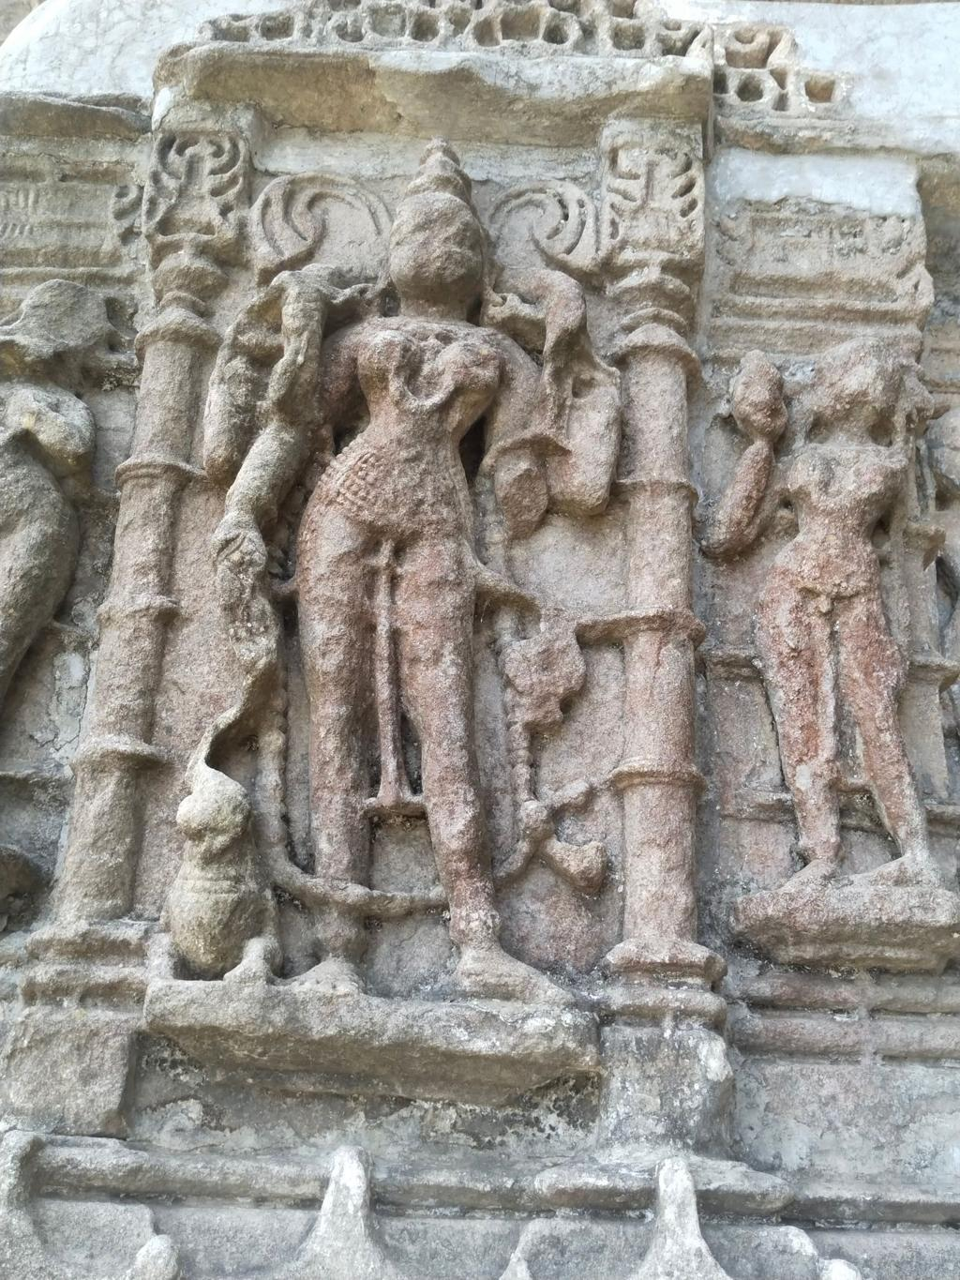

2. Temple Towers and Upper Sections
Some of the temples that once existed at Khajuraho have disappeared almost completely, leaving only foundations, lower walls or mounds. UNESCO's documentation notes that many of the original temples can now be traced through ruins and archaeological remains.
In surviving temples, the upper architectural sections have generally survived much better than the lost temples, but individual stones and decorative elements show deterioration.
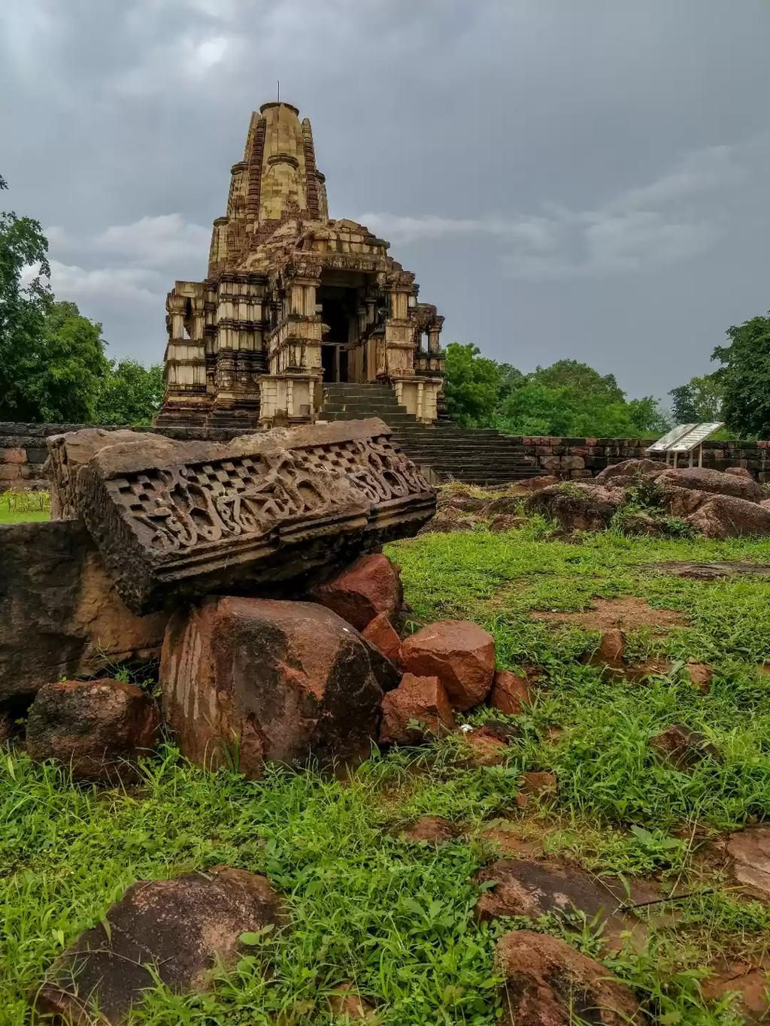

3. Decorative Panels
The outer walls contain extremely detailed bands of:
- Gods and goddesses
- Musicians and dancers
- Animals
- Mythological figures
- Human activities
- Decorative motifs
Some individual carvings have suffered surface erosion, loss of fine details and breakage.

4. Pillars, Doorways and Architectural Details
The temples contain intricately carved:
- Pillars
- Door frames
- Windows
- Brackets
- Cornices
- Small miniature shrine elements
Because these are made of sandstone and exposed to the environment, some have experienced surface weathering and loss of sharp carving details.

5. Chausath Yogini Temple
The Chausath Yogini Temple is one of the most visibly incomplete monuments at Khajuraho. It was built mainly from local granite, unlike many of the later sandstone temples.
The original structure had 65 cells, but only 35 cells survive today. This makes it a particularly good example for studying the extent of architectural loss at Khajuraho.
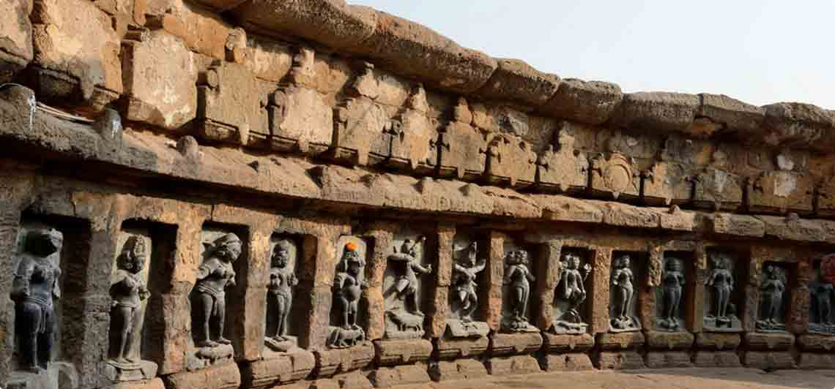

6. Lost Temples
Perhaps the greatest "damage" to Khajuraho is the loss of numerous temples altogether.
During the Chandella period, approximately 85 temples are thought to have existed at Khajuraho. Only around 22–23 monuments survive within the World Heritage property today. The remaining structures are represented by ruins, foundations and mounds.
Reference video:
https://youtu.be/q474V62zQ80?si=tMIGuhvyOR5zQpnn
Khajuraho is a historic temple complex in Madhya Pradesh, built mainly during the rule of the Chandella dynasty between the 10th and 11th centuries CE. The temples represent the peak of Nagara-style North Indian temple architecture. They were constructed primarily from sandstone and placed on elevated platforms called jagati.
Originally, a much larger number of temples existed at Khajuraho. Today, about 23 temples/structures form the protected World Heritage property, divided into Western, Eastern and Southern groups. The surviving monuments represent both Hindu and Jain traditions.
The temples are especially famous for their intricate sculptures. These depict deities, musicians, dancers, warriors, animals, everyday social life, and couples. Therefore, the famous erotic sculptures are only one component of a much broader artistic and religious programme.
Khajuraho was inscribed as a UNESCO World Heritage Site in 1986 for its outstanding architectural and artistic value.

Causes of Destruction and Damage of Khajuraho Temples
The Khajuraho temples were built mainly during the 10th–11th centuries. Their destruction was not caused by one single event. The loss of temples and damage to sculptures happened gradually through political changes, human activity, neglect, and natural weathering.

1. Political and Military Conflicts
During the medieval period, the Chandella kingdom faced conflicts and invasions. Changes in political control affected the protection and maintenance of the temple complex.
Some temples may have suffered damage during periods of conflict, although it is not accurate to attribute all the missing temples to a single invasion.

2. Decline of the Chandella Dynasty
The Chandellas gradually lost political power after the 12th century. As their political importance declined, Khajuraho also lost its position as a major royal and cultural centre.
With less royal patronage, regular maintenance and temple activities decreased, contributing to the gradual deterioration of the complex.

3. Abandonment and Neglect
When the temples were no longer actively maintained, vegetation and natural processes began affecting the structures.
Over many centuries:
- Plants grew around the monuments.
- Water entered cracks and joints.
- Stone surfaces became weaker.
- Some structures collapsed or became buried.

4. Natural Weathering
This is one of the most important causes of deterioration of the surviving temples.
Khajuraho's sandstone is exposed to:
- Heavy monsoon rainfall
- High summer temperatures
- Wind
- Moisture
- Repeated heating and cooling
Over hundreds of years, these processes have caused surface erosion and loss of fine sculptural details.

5. Water and Moisture
Monsoon water can enter joints and cracks in the stone. Repeated wetting and drying can gradually weaken the material.Poor drainage around a structure can also increase moisture-related deterioration.

Frequently Asked Questions (FAQ) – Khajuraho

1. Where is Khajuraho located?
Khajuraho is located in Chhatarpur district of Madhya Pradesh, India, in the Bundelkhand region.

2. Who built the Khajuraho temples?
The temples were mainly built by the Chandela rulers between the 9th and 12th centuries CE, with most construction taking place during the 10th and 11th centuries.

3. Why is Khajuraho famous?
Khajuraho is famous for its Nagara-style temple architecture and intricate stone sculptures, including religious, mythological, musical, social and erotic scenes.

4. How many temples were originally built?
Historical evidence suggests that around 85 temples once existed at Khajuraho. Only about 20–25 temples survive today, depending on how surviving structures and remains are counted.

5. How many temples survive today?
Approximately two dozen temples survive in the Khajuraho groups, with the best-preserved concentration in the Western Group.

6. Why were so many temples destroyed?
Their loss occurred over a long period due to political changes, abandonment, human damage, natural weathering and lack of maintenance. It is not correct to attribute all the destruction to one particular invasion.

7. What type of stone was used?
Most of the major temples were constructed using sandstone, which allowed craftsmen to create extremely detailed carvings.

8. What are the main groups of Khajuraho temples?
The monuments are generally divided into three groups:
- Western Group
- Eastern Group
- Southern Group
The Western Group contains some of the most famous temples, including Kandariya Mahadeva and Lakshmana Temple.

9. Are all the sculptures at Khajuraho erotic?
No. Erotic sculptures are only a small part of the overall sculptural programme. The temples also depict deities, musicians, dancers, warriors, animals, mythical creatures and scenes of everyday life.

10. What caused the sculptures to become damaged?
Damage resulted from weathering, rain, temperature changes, biological growth and human activity. Delicate projecting parts such as hands and facial features are particularly susceptible to damage.

11. What happened to Khajuraho after the Chandela period?
As the Chandela dynasty declined, Khajuraho gradually lost its political and cultural importance. Many temples were eventually abandoned and became surrounded by vegetation.

12. When was Khajuraho rediscovered?
The monuments attracted renewed attention during the 19th century, when British officials and archaeologists documented and studied the site.

13. Is Khajuraho a UNESCO World Heritage Site?
Yes. The Khajuraho Group of Monuments was inscribed on the UNESCO World Heritage List in 1986.

14. Why is Khajuraho important today?
Khajuraho is important because it preserves exceptional examples of medieval Indian architecture, sculpture, religious traditions and craftsmanship.

15. What is the most famous temple at Khajuraho?
The Kandariya Mahadeva Temple is generally considered the most magnificent and architecturally elaborate temple at Khajuraho. It is dedicated to Lord Shiva.

Cuisine of Khajuraho
The cuisine of Khajuraho reflects the rich and traditional food culture of Madhya Pradesh and the Bundelkhand region. The local food is generally simple, flavorful, and prepared using ingredients that are easily available in the region. Popular dishes include Dal Bafla, Bhutte Ka Kees, Poha, Jalebi, and Sabudana Khichdi. Traditional grains, pulses, corn, vegetables, and local spices are commonly used in these dishes. Together, they represent the simple yet diverse culinary traditions of Khajuraho and central India.
Timeline of Khajuraho
9th century → Chandela dynasty rises
↓
10th century → Major temple construction begins
↓
10th–11th century → Golden Age of Khajuraho
↓
12th century → Chandela decline
↓
13th–18th century → Abandonment & deterioration
↓
19th century → Rediscovery & documentation
↓
20th century → Conservation
↓
1986 → UNESCO World Heritage Site
↓
Today → Major cultural & tourist heritage site

